**HR Attrition Analysis**

Introduction : Welcome to the HR Attrition Analysis presentation, where we delve into key insights derived from our HR analytics database. Employee attrition is a critical aspect of workforce management, and understanding the underlying trends can provide valuable insights for retention strategies and organizational growth.

In this analysis, we explore various factors influencing attrition, such as demographics, job satisfaction, and work-related attributes. By examining these aspects, we aim to uncover patterns that can inform decision-making and contribute to the overall well-being and stability of our workforce.

Analysis:

create database HR_Analytics;

use HR_Analytics;

select * from hr_table;

**## 1. Employee Count**

SELECT COUNT(EmployeeCount) FROM hr_table;

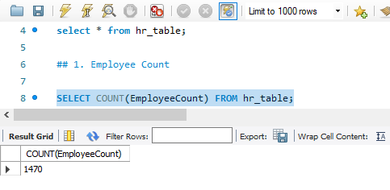

**## 2. Avg year at company**

SELECT ROUND(avg(YearsAtCompany), 2) FROM hr_table;

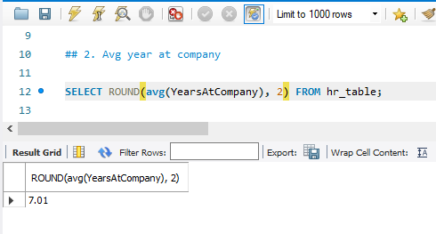

**## 3. Avg Age of Employee**

SELECT ROUND(AVG(Age), 0) FROM hr_table;

**## 4. Attrition Count**

SELECT COUNT(Attrition) as Attrition_Count FROM hr_table

WHERE Attrition = "Yes" ;

**## 5. Attrition Rate**

SELECT ROUND((SUM(CASE WHEN Attrition = 'Yes' THEN 1 ELSE 0 END) / COUNT(EmployeeCount)) * 100, 2) as AttritionRate

FROM hr_table;

**## 6. Attrition by Education**

SELECT

EducationField,

SUM(CASE WHEN Attrition = 'Yes' THEN 1 ELSE 0 END) as Total_Attrition,

ROUND((SUM(CASE WHEN Attrition = 'Yes' THEN 1 ELSE 0 END) / SUM(SUM(CASE WHEN Attrition = 'Yes' THEN 1 ELSE 0 END)) OVER ()) * 100, 2) as Percentage_of_Total_Attrition,

ROUND((SUM(CASE WHEN Attrition = 'Yes' THEN 1 ELSE 0 END) / COUNT(*)) * 100, 2) as AttritionPercentage

FROM hr_table

GROUP BY EducationField;

**## 7. Attrition by Age Group**

SELECT

(CASE WHEN Age BETWEEN 18 and 25 THEN "18-25"

WHEN Age BETWEEN 26 and 35 THEN "26-35"

WHEN Age BETWEEN 36 and 45 THEN "36-45"

WHEN Age BETWEEN 46 and 55 THEN "46-55"

ELSE "56 & Above"

END) Age_Group,

SUM(CASE WHEN Attrition = "Yes" THEN 1 ELSE 0 END) Total_Attrition

FROM hr_table

GROUP BY Age_Group

ORDER BY Age_Group;

**## 8. Attrition by Salary Slab**

SELECT

(CASE WHEN MonthlyIncome BETWEEN 5000 and 10000 THEN "5k-10k"

WHEN MonthlyIncome BETWEEN 10000 and 15000 THEN "10k-15k"

WHEN MonthlyIncome > 15000 THEN "15k+ "

ELSE "Upto 5k" END) Salary_Slab,

COUNT(CASE WHEN Attrition = "Yes" Then 1 ELSE 0 END) Attrition_Count

FROM hr_table

GROUP BY Salary_Slab

ORDER BY Salary_Slab;

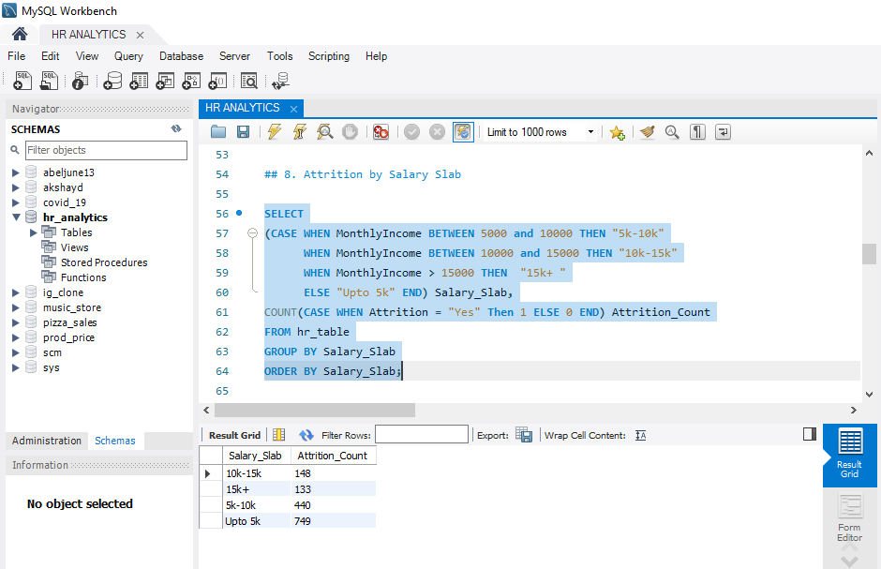

**## 9. Attrition by Job Role**

SELECT JobRole,

SUM(CASE WHEN Attrition = "Yes" THEN 1 ELSE 0 END) Total_Attrition

FROM hr_table

GROUP BY JobRole;

**## 10. Attrition by Year at Company**

SELECT YearsAtCompany,

SUM(CASE WHEN Attrition = "Yes" THEN 1 ELSE 0 END) Total_Attrition

FROM hr_table

GROUP BY YearsAtCompany

ORDER BY YearsAtCompany;

**## 11. Job Satisfaction by Role and Total Attrition**

SELECT JobRole, JobSatisfaction,

SUM(CASE WHEN Attrition = "Yes" THEN 1 ELSE 0 END) Total_Attrition

FROM hr_table

GROUP BY JobRole, JobSatisfaction

ORDER BY JobRole, JobSatisfaction;

**## 12. Attrition by Department**

SELECT Department,

SUM(CASE WHEN Attrition = "Yes" THEN 1 ELSE 0 END) Total_Attrition

FROM hr_table

GROUP BY Department;

**## 13. Attrition by Gender**

SELECT Gender,

SUM(CASE WHEN Attrition = "Yes" THEN 1 ELSE 0 END) Total_Attrition,

ROUND((SUM(CASE WHEN Attrition = "Yes" THEN 1 ELSE 0 END) / SUM(SUM(CASE WHEN Attrition = "Yes" THEN 1 ELSE 0 END)) OVER()) *100, 2) as Percentage_of_Total_Attrition

FROM hr_table

GROUP BY Gender;

**## 14. Attrition by Marital Status**

SELECT MaritalStatus,

SUM(CASE WHEN Attrition = "Yes" THEN 1 ELSE 0 END) Total_Attrition,

ROUND((SUM(CASE WHEN Attrition = "Yes" THEN 1 ELSE 0 END) / SUM(SUM(CASE WHEN Attrition = "Yes" THEN 1 ELSE 0 END)) OVER()) *100, 2) as Percentage_of_Total_Attrition

FROM hr_table

GROUP BY MaritalStatus;

**## 15. Attrition by WorkLife Balance**

SELECT WorkLifeBalance,

SUM(CASE WHEN Attrition = "Yes" THEN 1 ELSE 0 END) Total_Attrition

FROM hr_table

GROUP BY WorkLifeBalance;

**## 16. Attrition by Business Travel**

SELECT BusinessTravel,

SUM(CASE WHEN Attrition = "Yes" THEN 1 ELSE 0 END) Total_Attrition

FROM hr_table

GROUP BY BusinessTravel;

**## 17. Attrition by Environment Satisfaction**

SELECT EnvironmentSatisfaction,

SUM(CASE WHEN Attrition = "Yes" THEN 1 ELSE 0 END) Total_Attrition

FROM hr_table

GROUP BY EnvironmentSatisfaction

ORDER BY EnvironmentSatisfaction;

**## 18. Attrition by Distance From Home**

SELECT DistanceFromHome,

SUM(CASE WHEN Attrition = "Yes" THEN 1 ELSE 0 END) Total_Attrition

FROM hr_table

GROUP BY DistanceFromHome

ORDER BY DistanceFromHome;

**Summary:**

As a data analyst, I have conducted an in-depth HR Attrition Analysis using the provided SQL queries on the HR analytics database. The objective was to gain insights into employee attrition trends and identify key factors influencing workforce stability. Let's distill the findings:

1. **Employee Overview:**
   * The organization currently has 1470 employees.
   * The average tenure at the company is 7.01 years, indicating a relatively stable workforce.
   * The average age of employees is 37 years.
2. **Attrition Metrics:**
   * 237 employees have left the company.
   * The overall attrition rate is 16.12%, suggesting the need for a closer examination of contributing factors.
3. **Demographic Analysis:**
   * **Education Impact:**
     + Attrition varies across education fields, with 37.55% being the highest in Life Science.
   * **Age Insights:**
     + The age group 18-25 experiences the highest attrition, emphasizing the importance of age-related considerations.
4. **Financial Factors:**
   * **Salary Impact:**
     + Employees with monthly incomes in up to 5k have a higher attrition rate, highlighting potential financial factors influencing attrition.
5. **Job-related Factors:**
   * **Job Roles:**
     + Certain job roles, such as Sales Executive, exhibit higher attrition rates.
   * **Tenure Influence:**
     + Attrition varies based on the number of years an employee has been with the company, providing insights into retention challenges.
6. **Job Satisfaction and Work Environment:**
   * **Job Satisfaction:**
     + Employees in Laboratory Technician with 3 star job satisfaction levels exhibit higher attrition.
   * **Departmental Impact:**
     + Attrition differs significantly across departments, with Research and Development having the highest attrition.
7. **Personal Factors:**
   * **Gender Impact:**
     + Attrition varies between genders, with 63.29 in Male.
   * **Marital Status:**
     + 50.63% of single employees experience attrition.
8. **Work-life Balance and Well-being:**
   * **Work-life Balance:**
     + Employees who gives point 3 work-life balance experience higher attrition.
   * **Business Travel Impact:**
     + Frequent business travel is associated with higher attrition.
9. **Employee Satisfaction Metrics:**
   * **Environment Satisfaction:**
     + Employees with 1 satisfaction levels exhibit higher attrition.
   * **Distance from Home:**
     + Attrition is influenced by the distance of the workplace from home.

In conclusion, this analysis provides actionable insights for HR interventions, emphasizing the importance of addressing factors such as job satisfaction, financial considerations, and work-life balance. These findings lay the foundation for data-driven decision-making, enabling targeted strategies for employee retention and organizational growth.